WEEK 1 INTERNSHIP ASSIGNMENT
ONLINE RETAIL DATA CLEANING, PREPROCESSING AND ANALYSIS

Internship Organization: [Yuva.Intern]
Internship Duration: 29 September 2026 – 10 November 2026
Assignment: Week 1 – Online Retail Data Cleaning
Dataset: UCI Online Retail Dataset
Prepared by: Shreya Dolui
Date: 29 September 2026

Introduction
This report presents the data acquisition, data cleaning, preprocessing, feature engineering and exploratory analysis performed on the Online Retail dataset as part of the Week 1 internship assignment.
The main objective of this assignment was to understand the structure and quality of the dataset, identify and handle missing values, duplicate records, cancelled transactions and invalid values, create useful features, and perform basic exploratory sales analysis.
The complete analysis was performed using Python in Google Colab with libraries including Pandas, NumPy, Matplotlib and Seaborn.

Dataset Source and Description
The dataset used for this assignment is the Online Retail Dataset obtained from the UCI Machine Learning Repository. It contains transactional information from an online retail business.
Dataset Name: Online Retail
Original File: Online Retail.xlsx
Original Dataset Size: 541,909 rows × 8 columns

Column | Description
InvoiceNo | Invoice number identifying a transaction
StockCode | Product/item code
Description | Description of product
Quantity | Number of item purchased
InvioceDate | Date and time of the transaction
UnitPrice | Price per item
CustomerID | Identification number of the customer
Country | Country of the customer

Data Acquisition
The Online Retail dataset was obtained from the UCI Machine Learning Repository. The original dataset was provided in Excel format as Online Retail.xlsx. The file was uploaded to Google Colab and loaded into a Pandas DataFrame using Python for further exploration, cleaning and analysis.
Tools Used:
Google Colab
Python
Pandas
NumPy
Matplotlib
Seaborn

Initial Data Exploration
Initial data exploration was performed to understand the structure, size, columns, data types and statistical characteristics of the Online Retail dataset. The dataset was inspected using Pandas functions such as head(), shape, columns, info() and describe().
Original Dataset Shape: 541,909 rows x 8 columns
The initial inspection showed that the dataset contained missing values in the Description and CustomerID columns. It also contained negative Quantity values and non-positive UnitPrice values, which were investigated during the cleaning process.

Missing Value Analysis
Missing values were checked using Pandas to identify incomplete records in the dataset. In the original dataset, the Description column contained 1,454 missing values, while the CustomerID column contained 135,080 missing values.
Rows with missing Description and CustomerID values were removed because these fields were required for meaningful product-level and customer-level analysis.
Missing Values Identified:
Column | Missing Values
Description | 1454
CustomerID | 135,080

Duplicate Data
Duplicate records were checked before preprocessing. A total of 5,268 duplicate rows were identified in the original dataset and removed during the cleaning process.
After removing the duplicate records, the dataset contained 536,641 rows, and no duplicate rows remained.
Duplicate Records Identified: 5,268
Duplicate Records Remaining: 0
Data Cleaning and Validation
The dataset was cleaned and validated to remove records that could affect the accuracy of the analysis. Invoice numbers beginning with the letter “C” were treated as cancelled transactions according to the dataset documentation. A total of 8,872 cancelled transactions were identified and removed.
Quantity values were then checked for invalid negative values. After removing the cancelled transactions, no negative Quantity values remained.
UnitPrice values were also validated. 40 records had a UnitPrice less than or equal to zero, and these records were removed.
Outliers in Quantity and UnitPrice were examined using boxplots. Extreme values were not automatically removed because some unusually large transactions may represent legitimate purchases.

Feature Engineering
Feature engineering was performed to create additional variables that could support further analysis. A new column named TotalAmount was created by multiplying Quantity by UnitPrice.
TotalAmount = Quantity × UnitPrice
Additional date-related features were extracted from InvoiceDate to support time-based analysis. These features were:
Year — year of the transaction
Month — month of the transaction
Day — day of the transaction
Hour — hour of the transaction
After feature engineering, the final dataset contained 13 columns.
Before vs After Cleaning
The number of records was compared at different stages of the data cleaning process to measure the impact of preprocessing.
Stage | Rows
Original dataset | 541,909
After removing duplicates | 536,641
After removing missing Description/CustomerID | 401,604
After removing cancellations | 392,732
After removing non-positive UnitPrice | 392,692
Final cleaned dataset | 392,692

The dataset was reduced from 541,909 original records to 392,692 clean records after applying the required preprocessing steps.
Final Dataset Verification
The final dataset was verified after completing all preprocessing steps. The cleaned dataset contains 392,692 rows and 13 columns. All missing values and duplicate records were removed successfully.
The final dataset was also checked to confirm that the required data types were appropriate for further analysis.

Verification | Result
Final Rows | 392,692
Final Rows | 13
Final Rows | 0
Final Rows | 0

Exploratory Sales Analysis: Overall Sales Metrics
After completing the data cleaning and preprocessing steps, basic sales metrics were calculated to understand the overall performance of the cleaned dataset.

Metric | Value
Total Sales | 8,887,208.894
Average Order Value | 22.6315
Total Quantity Sold | 5,152,002
Number of Transactions | 18,532

The cleaned dataset recorded total sales of approximately 8.89 million, with 5,152,002 units sold across 18,532 unique transactions.
Country-wise Sales Analysis
Sales were grouped by country and sorted in descending order to identify the countries with the highest total sales. The following table shows the top 10 countries based on total sales.
Country | Total Sales
United Kingdom | 7,285,024.644
Netherlands | 285,446.340
EIRE | 265,262.460
Germany | 228,678.400
France | 208,934.310
Australia | 138,453.810
Country | Total Sales
Spain | 61,558.560
Switzerland | 56,443.950
Belgium | 41,196.340
Sweden | 38,367.830
The United Kingdom recorded the highest total sales among the countries in the cleaned dataset.
Product-wise Sales Analysis
Product-level sales were analyzed by grouping the cleaned dataset by product description and calculating the total sales for each product. The following table presents the top 10 products based on total sales.

Product | Total Sales
PAPER CRAFT , LITTLE BIRDIE | 168,469.60
REGENCY CAKESTAND 3 TIER | 142,264.75
WHITE HANGING HEART T-LIGHT HOLDER | 100,392.10
JUMBO BAG RED RETROSPOT | 85,040.54
MEDIUM CERAMIC TOP STORAGE JAR | 81,416.73
POSTAGE  Product | 77,803.96  Total Sales
PARTY BUNTING | 68,785.23
Product | Total Sales
ASSORTED COLOUR BIRD ORNAMENT | 56,413.03
Manual | 53,419.93
RABBIT NIGHT LIGHT | 51,251.24
The results show differences in sales contribution across products, with PAPER CRAFT , LITTLE BIRDIE having the highest total sales among the listed products.
Monthly Sales Trend
Monthly sales were analyzed using the Year and Month features created during preprocessing. A line chart was used to visualize the sales trend over the available period.
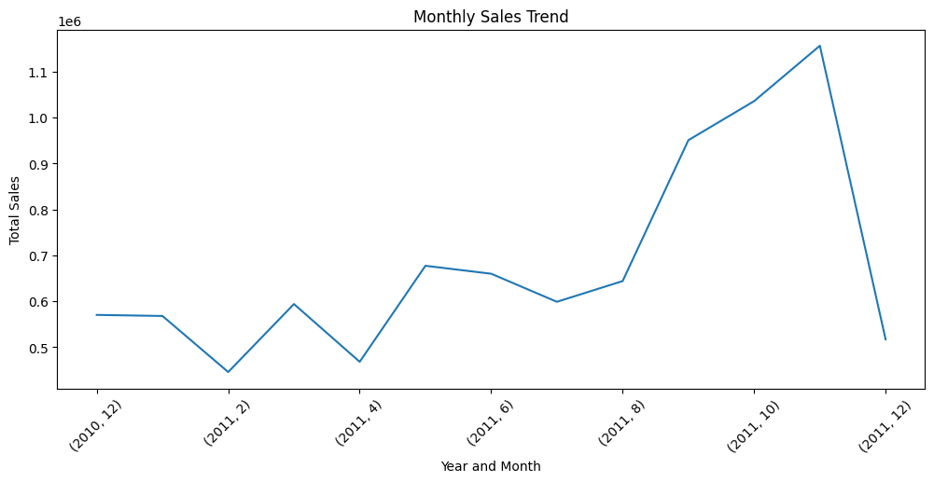
Key Findings
- The original dataset contained 541,909 records.
- After preprocessing, 392,692 clean records remained.
- Missing values and duplicate records were removed.
- Cancelled transactions and non-positive UnitPrice records were excluded.
- Total sales were approximately 8.89 million.
- The United Kingdom recorded the highest total sales.
- Sales varied across products and months.
Challenges Faced
The main challenges during the data preprocessing process were handling missing values, duplicate records, cancelled transactions, invalid UnitPrice values and extreme values in Quantity and UnitPrice. These issues were addressed using Python and Pandas through systematic data cleaning and validation.
Impact of Data Preprocessing
Data preprocessing improved the quality and consistency of the dataset by removing duplicate, incomplete and invalid records. The creation of TotalAmount and date-related features also made the dataset more suitable for sales analysis and visualization.

Conclusion

The Online Retail dataset was successfully acquired, explored, cleaned and prepared for analysis using Python and Pandas. After preprocessing, the final dataset contained 392,692 records and 13 columns, with no missing values or duplicate rows.
Basic sales analysis was performed to understand overall sales, country-wise sales, product-wise sales and monthly sales trends. This assignment provided practical experience in data cleaning, preprocessing, feature engineering and exploratory data analysis.

